**RENU GOYAL**

**Business Analyst**

**+1 647-676-8574 | REINGOYAL@GMAIL.COM**

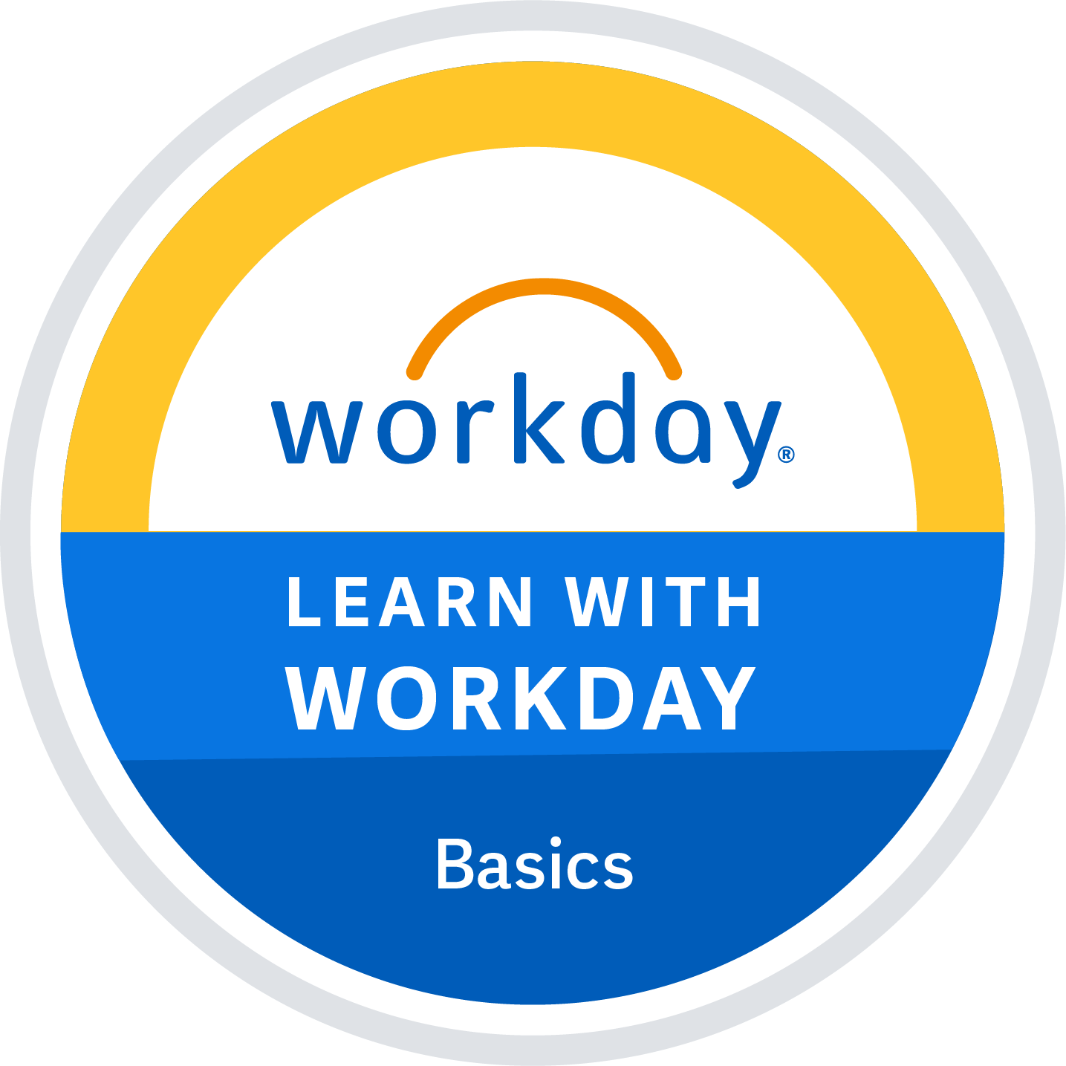

**Summary**

* Dedicated Professional with 14+ years of experience in Business Analysis and Quality Assurance working in Securities & Capital Markets, Workday HCM and Telecom domains.
* Expertise with the entire SDLC, stakeholder management, Requirements Gathering, Effective Communication and presentation skills, Business Artifacts documentation, Statistical /Data analysis, Current & future Gap Analysis and Business Process mapping.
* Strong analytical and problem-solving skills.
* Excellent communication and interpersonal skills, with the ability to collaborate effectively with cross-functional teams and stakeholders.

# Professional Experience\

# Business Analyst/Client Adoption Analyst

# CIBC MELLON, CANADA | Robertson & Company Ltd

11/ 2021 – 04/2024

* Collaborated with stakeholders to gather and document business requirements for migration of financial reports from legacy to iHub platform.
* Provided best workable solutions to client data requirements.
* Conducted stakeholder interviews and brainstorming sessions to elicit requirements and gathered feedback.
* Developed detailed requirement documents like (BRD), Transition documents, Quick Reference Guides (QRG), Mapping Documents, user stories and training Documents for Client Migration.
* Performed source system data analysis to manage source to target data mapping using Advance Excel (VLOOKUP, Pivot tables).
* Analyzed Current and Future State workflow, Gap Analysis.
* Handled Financial Data migration from legacy system to new system.
* Ensured adherence to regulatory requirements by developing and maintaining comprehensive documentation and reports for audits and compliance checks.
* Ensured data integrity and accuracy by helping in testing reports migrate to new platform.
* Identified inefficiencies in current system reporting system and proposed solutions to streamline operations and enhance productivity in new system.
* Developed and tested Interactive View (IVR) Templates of reports in BNYM (Bank of New York Mellon) tool - NEXEN.
* Managed bug tracking and issue resolution in Jira ensuring timely resolution of defects and alignment with project timelines.
* Managed product/functional roadmap for end-to-end delivery of project
* Provide end-user support and training to ensure smooth adoption of new systems and processes.
* Involved in Production deployments.

## Business Analyst/Product Owner

## SHAW CABLE/FREEDOM MOBILE, CANADA| Wipro Technologies

07/ 2021 – 11/2021

* Involved in meeting with stakeholders and senior management to understand application and gather requirements.
* Created user stories in Jira from the requirements to convert window application to web based.
* Product backlog refinement.
* Collaborated with cross-functional teams to develop business process models, workflow diagrams, system integration, and data management.
* Demonstrated to Stakeholders after end of each sprint.
* Reviewed Test Plans and test scenarios created by QA team, helped in Test execution.
* Worked on APIs for integration.
* Defect management with the client till the closure phase.
* Knowledge sharing and training other team members.
* Conducted user training and adoption efforts for new systems and processes, providing guidance and support to end-users to facilitate successful implementation and utilization.
* Collaborated with clients and internal teams to troubleshoot technical issues and implement solutions.

## Business Analyst/QA Lead/SME/Scrum Master

## STATE STREET BANK, USA | Wipro Technologies

## 03/2015 – 07/2021

* Participated in system enhancement and upgrade projects, providing input on business requirements.
* Collaborated closely with product owners, stakeholders, and development teams to prioritize and manage product backlogs.
* Facilitated agile ceremonies including sprint planning, daily stand-ups, sprint reviews, and retrospectives, fostering collaboration, transparency, and continuous improvement within the team.
* Elicited, analyzed, and documented user stories, acceptance criteria, and business requirements, ensuring that they were clear, concise, and actionable for development teams.
* Championed agile best practices, facilitated knowledge sharing sessions, and provided mentorship to team members to promote a culture of continuous learning and improvement.
* Played a key role in gathering and analyzing information from various platforms to support decision-making processes and recommend appropriate solutions.
* Assisting with Pre and Postproduction activities as needed.
* Tested execution on Orders management, routing and venue executions Trading Infrastructure applications for Equities, Options-all strategies, Futures -Options, Fixed Income, FOREX, Global stock orders.
* Knowledge of Testing compliance reports for Financial Regulatory process for SEC.
* Developed an automated Tool in RTC to upload sprint tasks and helped in increasing the velocity by 15-20% every iteration.
* Well versed in analyzing Results, Bug Tracking & Reporting, Detailed status reporting.
* Worked with QA team in creation and implementation of Test Procedures, Test Plans and Test Scripts, defining Test Cases, reviewing, execution and fixing the errors.

## Business Analyst/QA Lead

## CHARLES SCHWAB, USA | Wipro Technologies

06/ 2014 – 03/2015

* Facilitated communication and collaboration between business stakeholders and IT teams, ensuring that technical solutions met business requirements and regulatory standards.
* Provided post-implementation support and ongoing maintenance for Market Data systems, addressing issues, implementing enhancements, and optimizing performance.
* Provided lifecycle management of Functional and Regression testing projects on Market Data Servers, Applications and databases using Client Tools, Test Management tools and various monitoring and scripting tools.
* Verified SRS and reporting Ambiguities, Created Test scenarios, Reviewed and Executed and defect reporting.
* Participated in Signing-Off releases.
* Maintained parallel communication with Client-side developers and performed Data validation with respect to Third Party Data providers named Bloomberg.
* Collaborated cross-functionally with development teams to integrate applications using API testing tools MAMA API, SoapUI, ensuring comprehensive validation of RESTful APIs and enhancing overall API reliability.
* Established secure connections to remote servers using SSH for receiving Market Server data, performing log analysis, and troubleshooting issues.
* Performed End to End testing across all Market data layers, verifying Open-Close, Day High-low and Trade and Quote data, L1 and L2 data, Reference data of any Stock Symbol.

`

## QA Lead/SME

## STATE STREET BANK, USA | Wipro Technologies

01/ 2011 – 06/2014

* Led requirements gathering and analysis efforts in project to convert Relational Ledger application based on main frame system to Web conversion and supported development teams and systems integration.
* Collaborated closely with stakeholders to elicit, prioritize, and document business requirements, ensuring alignment with organizational goals and objectives.
* Utilized industry-standard methodologies such as Unified Modeling Language (UML), Business Process Model and Notation (BPMN), and Entity-Relationship Diagrams (ERDs) to model and document business processes and system requirements.
* Leveraged tools Microsoft Visio to create process diagrams, workflow diagrams, and data models, ensuring clear and accurate representation of business requirements and system designs.
* Developed and executed Test Cases, interacted with developers to fix the errors.
* Performed various levels of testing -Smoke testing, Functional testing, Regression testing, Web Testing, UI Testing, UAT Testing.
* Defect management and Discussion of defects with the client till the closure phase.
* Shared Knowledge and provided training to other team members.
* Assisted team in Pre and Postproduction activities as needed, Signing-Off releases.
* Assessed backend applications by writing SQL and PL/SQL statements.

## QA Tester/UI Developer

## HRM (Human Resource Management) | Nucleus Software Exports Ltd

## ACOM, JAPAN | Nucleus Software Exports Ltd

## BANK OF BAHRAIN & KUWAIT, BAHRAIN | Nucleus Software Exports Ltd

## 04/2008– 01/2011

* Interacted with Business Analysts and Translation Team to gather and understand the business requirements and developed ACOM application.
* Led the development, implementation and customization ofHRM application
* Work closely with the HR PMO resources to ensure an accurate project roadmap and prioritization of work.
* CSS implementation, UI Development and testing applications of BBK, Bahrain.

# Skills Matrix

|  |  |
| --- | --- |
| **Business Analysis Tools** | Atlassian JIRA, Confluence, Microsoft Visio, IBM Rational Team Concert |
| **App Lifecycle Management tool** | HP Quality Center, IBM Rational Clear Quest, Team Foundation Server |
| **Project Management** | Agile, Scrum, Waterfall |
| **Operating Systems** | Windows, HP Unix, Linux, Mainframe |
| **Tools** | MS Office, MS Word, Advance Excel, PowerPoint presentation, Share Point, MS Teams, Outlook ClearCase, SVN, BNYM Tool NEXEN |
| **IDEs** | Visual Studio, TFS-MTM, JDeveloper, Eclipse, IBM Rational Application Developer, TOGAF, JDeveloper, Eclipse, IBM Rational Application Developer |
| **Programming and scripting Languages** | HTML, XML, JSP/Java |
| **Data Analysis & Visualization** | Excel, SQL, Oracle, Tableau. |
| **Messaging Protocols** | TCP/IP, FIX Protocol, SFTP, SSH, BESS (Swift Messages) |
| **Browsers** | Chrome, Firefox, IE, Safari |
| **ERP(SaaS)** | Workday HCM |
| **Types of Testing** | Functional, Regression, UAT, System Integration, Performance and Failover, Build smoke testing, Ad hoc and Exploratory testing. |
| **Misc.** | Beyond compare, Putty, MS Visio, Power Automate, HP QTP/UFT, TAF (Tool Agnostic Framework), Selenium, Tableau, Power BI, snag it, Snipping Tool, Beyond Compare, WinSCP, Text pad, Notepad++, One Note, Conversion Billing (CB), PEWEB SingleView, Cloud AWS Dynamo, DB Sentinel log/Cardinal Portal, Orthogonal Array |

**Education**

Bachelor of Technologies in Computer Science & Engineering (INDIA) 2003-2007

Post Graduate Diplôma in Information Technology (INDIA) 2010-2012

**Certifications**

Workday Basics Series from Workday

Workday in Action Series from Workday

Certified Scrum Master (CSM) - Scrum Alliance (CSM)

Business Analysis Foundations

Learning Microsoft Dynamics 365 : The Basics

**References:** Available upon request.